Stationery - Research in Action
Subject line: Research in Action Newsletter – September 2023
ADD IN BELOW HEADER: September 2023 – Latest research news and updates from MS Canada
Think someone you know may be interested in getting this newsletter? Forward this on and they can subscribe here.

In This Edition

Research Updates: A Promising Non-Invasive Therapy to Promote Remyelination | Prevalence and Treatment of Diabetes and Hypertension | Identifying Blood-based Markers
Spotlight: Dr. Scott Patten & MSCanRehab
Get Involved: MS Hear from the Experts - Cognition

Spotlight

Dr. Scott Patten

Dr. Scott Patten is a member of MS Canada’s Medical Advisory Committee. Dr. Patten obtained a medical doctorate (MD) from the University of Alberta (Edmonton, Canada) in 1986 and subsequently a specialist certification (FRCPC) in Psychiatry in 1991. He completed a Ph.D. in epidemiology at the University of Calgary in 1994. Currently, he is a Professor in the Cumming School of Medicine at the University of Calgary, where he teaches Advanced Epidemiology. His research is concerned with the descriptive epidemiology of common mental disorders (especially depression) and medical-psychiatric comorbidity in the Canadian population. Dr. Patten is also leading the CanProCo site at the University of Calgary.
[LEARN MORE]

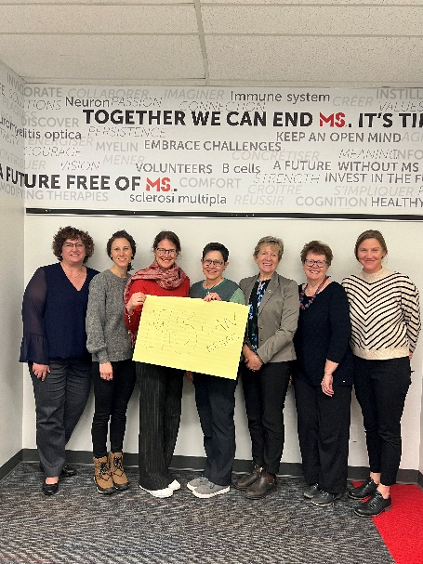
MSCanRehab - A network of Canadian rehabilitation researchers and clinicians
To accelerate advances in MS rehabilitation, a team of multi-disciplinary rehabilitation researchers and clinicians from across Canada have come together to form a collaborative network called ‘MSCanRehab.’ MSCanRehab brings together leaders with expertise in physiatry, neuropsychology, physical therapy, occupational therapy, exercise physiology, clinical epidemiology, and neuroscience.

By establishing a network, MSCanRehab can more quickly and efficiently develop and test novel approaches, therapies, and technologies aimed at restoring function in people living with MS.

“By bringing Canadian rehabilitation scientists together, MSCanRehab is setting research priorities and conducting collaborative clinical rehabilitation trials to move the field forward at a faster pace.” – Dr. Michelle Ploughman
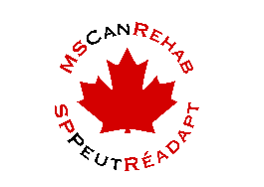
[READ MORE]

____________________________________________________________________________________
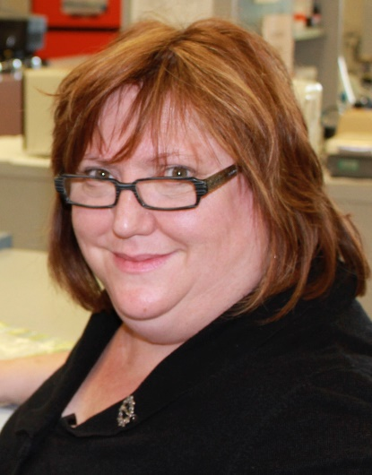
Research Updates
A Promising Non-Invasive Therapy to Promote Repair and Remyelination in Multiple Sclerosis

Researchers find that a non-drug based treatment approach called acute intermittent hypoxia (AIH), which consists of short periods of reduced oxygen, reduces inflammation, protects nerve fibres, and promotes repair in mice with multiple sclerosis-like disease. While the findings of this study are promising, further research will need to assess whether this treatment has the same effect in people with MS.

[READ MORE]

Watch a video from Dr. Valerie Verge explaining the study – here.
-------------------------------------------------------------------------------------------------------------------------------------
Prevalence and Treatment of Diabetes and Hypertension in People with Multiple Sclerosis

A population-based study in the UK examined the prevalence and treatment of type 2 diabetes and hypertension in people living with multiple sclerosis at time of their MS diagnosis compared to the general population. The study found an increased prevalence of hypertension and type 2 diabetes in people living with MS compared to the general population, along with lower rates of treatment for these conditions. Based on these findings, improved clinical guidelines are needed to better support people living with MS and these conditions.

[READ MORE]

------------------------------------------------------------------------------------------------------------------------------------------
Identifying Blood-based Markers Associated with Disease Progression in MS

Researchers investigated a blood-based marker called glial fibrillary acidic protein (GFAP), to understand whether it is associated with disease progression in multiple sclerosis (MS). GFAP was found to be associated with progression and future risk of disease progression in MS and serves as a potential biomarker. Identifying and validating biomarkers of disease progression will be important for developing new therapies and improving care for people living with MS.

[READ MORE]

Keep up to date with the latest research – [here].

_____________________________________________________________________________________
Get Involved

MS Hear From the Experts
MS Hear From The Experts is a series of webinars that aim to help people better understand MS, highlight MS-related resources, and provide tools and tips to navigate their MS journey with more knowledge and confidence. This series helps individuals learn more about the disease, treatments, research, wellness strategies, MS Canada programs and services, and much more.
Join us to learn more about setting wellness goals that can make positive changes to enhance your quality of life, even when there may be some bumps in the road along your journey. The next session is entitled ‘Cognition’ on Tuesday, September 5th from 7-8pm EST.
[REGISTER HERE]

In Case You Missed It!
Community Representatives 2024: profiles
In 2012, an initiative was launched to involve people in the MS community – termed Community Representatives – in the review process for the annual research competition. Through this, MS Canada hopes to provide a voice for people affected by MS and enable them to meaningfully inform research priorities and allocation of research dollars.
[LEARN MORE]
--------------------------------------------------------------------------------------------------------------------------------------
MS in the News

Check out this article from The New Yorker, highlighting Canadian MS researcher Dr. Jiwon Oh and her perspective on the remarkable progress made in the field of MS research over the years. Dr. Oh is the lead researcher of the Canadian Prospective Cohort Study we’re funding, which focuses on better understanding Progression in MS.

Research Study

Multiple sclerosis and medical assistance in dying: A qualitative exploration of patient and family-centered care

To better understand the perspectives, knowledge, knowledge-seeking behaviours, experiences, and needs of individuals who are living with multiple sclerosis, their family members, friends or supporters, and care providers regarding end-of-life planning/goals of care and/or, palliation and/or medical assistance in dying (MAID).

This study will occur in Saskatchewan (the main cities of Regina and Saskatoon, and outreach to rural and remote regions). You can participate if, you are an individual living with MS who lives in Saskatchewan, is 18 years and older and has been diagnosed with MS for at least a year. Care partners/supports can participate if they are Saskatchewan residents, 18 years or older and are a care partner/support of an individual living with MS.

If interested, please contact Janine Brown at janine.brown@uregina.ca.

[LEARN MORE]

Interested in a research topic or event that was not covered? Submit your feedback to msresearchgrants@mscanada.ca

