Stationery - Research in Action
Subject line: Research in Action Newsletter – June 2023
ADD IN BELOW HEADER: June 2023 – Latest research news and updates from MS Canada
Think someone you know may be interested in getting this newsletter? Forward this on and they can subscribe here.

In This Edition

Research Updates: Health Care Costs Associated with MS | Fractalkine | First-Trimester Miscarriages in Women with MS
Spotlight: Beverley MacAdam & Dr. Anthony Feinstein
Get Involved: A novel and adaptive robotics rehabilitation approach to improve upper limb function in people with MS

Exciting news!

The MS Society of Canada has a new name and new website! Learn more about MS Canada at www.mscanada.ca
____________________________________________________________________________________

Spotlight

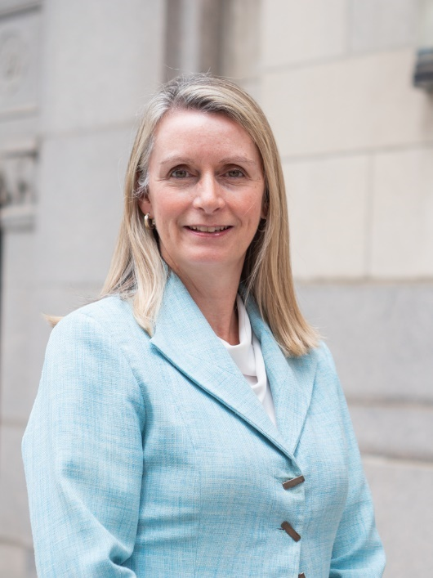
Beverley MacAdam

MS Canada would like to welcome Beverley MacAdam as the newest member of the Medical Advisory Committee. Beverley is a Senior Director at RBC and has been an avid volunteer with MS Canada for the past several years by participating on the organizing committee for the Toronto Women Against MS (WAMS) Gala Luncheon and as a Community Representative for the Annual Research Competition. She hopes that research will lead to the development of novel treatments that will allow for easier management of the disease and eventually an end to MS for future generations.

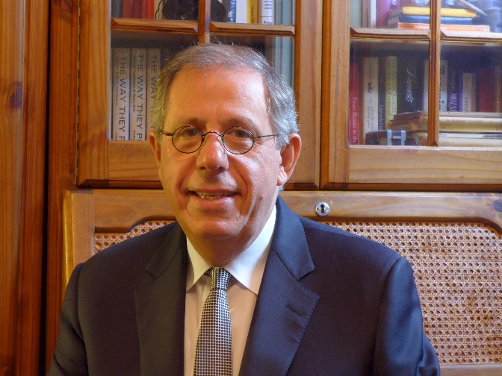
Giants of Multiple Sclerosis Award – Dr. Anthony Feinstein
Dr. Anthony Feinstein, a Canadian researcher at the University of Toronto, is one of the recipients of this year’s Giants of Multiple Sclerosis award in the category of mental health, by NeurologyLive® and the Consortium of Multiple Sclerosis Centers (CMSC). The Giants of Multiple Sclerosis award recognizes individuals who have made significant contributions to the field of multiple sclerosis. Dr. Anthony Feinstein and nine other awardees were selected from over 200 global nominations. Congratulations!
[LEARN MORE HERE]

____________________________________________________________________________________
Research Updates
First-Trimester Miscarriages in Women with MS

Canadian researchers study first-trimester miscarriages in Canadian women with multiple sclerosis (MS). The study followed 205 women with MS and found similar rates of first-trimester miscarriages compared to the general population. These findings offer reassurance to women with MS and their healthcare providers when discussing family planning.

[READ MORE]

-------------------------------------------------------------------------------------------------------------------------------------
Fractalkine: A Potential MS Therapeutic that Enhances Repair and Regeneration

Researchers led by Dr. Anastassia Voronova found that an immune system molecule called fractalkine promoted repair of myelin, the protective coating surrounding nerve fibers, in the brain of mice with multiple sclerosis-like disease. The findings of this study demonstrate fractalkine as a potential therapeutic for multiple sclerosis to enhance repair and regeneration.

[READ MORE]

[WATCH HERE]
------------------------------------------------------------------------------------------------------------------------------------------
Health Care Costs Associated with MS

CanProCo researchers calculate the annual direct medical costs of multiple sclerosis (MS) in British Columbia, Canada and find it is almost four times greater than for those without MS. Direct medical costs associated with MS are driven primarily by the costs of disease-modifying therapies (DMTs), followed by hospitalizations and then outpatient care (e.g., physician visits). Effective disease management strategies and policies guiding affordability and reimbursement of DMTs will be important in reducing the economic burden of MS and improving the quality of life of people living with MS.

[READ MORE]

_____________________________________________________________________________________
Get Involved

MS Hear From the Experts
MS Hear From The Experts is a series of webinars that aim to help people better understand multiple sclerosis, highlight MS-related resources, and provide tools and tips to navigate their MS journey with more knowledge and confidence. This series helps individuals learn more about the disease, treatments, research, wellness strategies, MS Canada programs and services, and much more.
Join us to learn more about setting wellness goals that can make positive changes to enhance your quality of life, even when there may be some bumps in the road along your journey. The next session is entitled ‘Working with Your Pharmacy’ on Tuesday June 6th from 7-8pm EST.
[REGISTER HERE]
------------------------------------------------------------------------------------------------------------------------------------------

In Case You Missed it:

MS Canada congratulates the applicants who have been awarded funding in the 2023-2024 Research Competition! There were a total of 68 award recipients this year, of which 51 were trainee awards supporting the next generation of MS researchers! Click below to learn more about the projects funded.

[READ MORE]
_____________________________________________________________________________________Research Study

A novel and adaptive robotics rehabilitation approach to improve upper limb function in people with MS

Researchers at Brock University are conducting a study to determine the effects of an adaptive upper limb robotic rehabilitation training program on clinical and functional outcomes in both the trained and untrained limbs in individuals with MS.

The study is recruiting participants with MS who have at least some function in one of the wrists or upper limbs. A state-of-the-art robotic device will be used to provide repetitive and individually tailored movement therapy to each participant. Findings from this study will provide new knowledge and encourage robotics research in MS.

Recruitment closes December 31, 2023. For more information, contact Kailynn Mannella at km14ta@brocku.ca.

[LEARN MORE]

Interested in a research topic or event that was not covered? Submit your feedback to msresearchgrants@mssociety.ca

