Stationery - Research in Action
Subject line: Research in Action Newsletter – January 2024
ADD IN BELOW HEADER: January 2024 – Latest research news and updates from MS Canada
Think someone you know may be interested in getting this newsletter? Forward this on and they can subscribe here.

In This Edition

Research Updates: Accelerating Research for a World Free of Multiple Sclerosis | Results from CogEx Clinical Trial | Researchers Uncover First Genetic Factor Associated with Disease Severity in Multiple Sclerosis
Spotlight: Dr. Elisabet Jakova
Get Involved: Participate in the CircaMS Study

Spotlight

Dr. Elisabet Jakova, SCN-MS Canada Postdoctoral Fellowship in Regenerative Medicine for Multiple Sclerosis
MS Canada partnered with the Stem Cell Network to support a Postdoctoral Fellowship in Regenerative Medicine for MS that aims to attract the most promising young scientists at the intersection of stem cells, regenerative medicine, and MS.

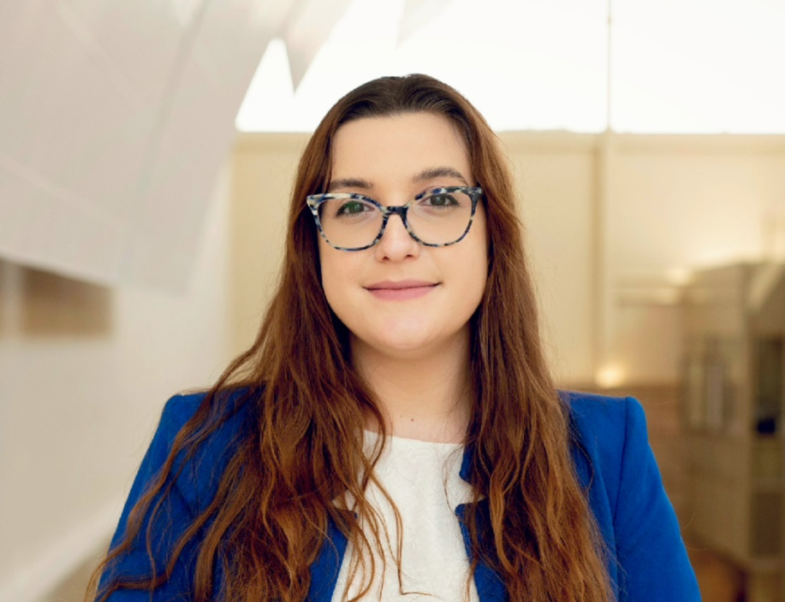
Dr. Elisabet Jakova’s research will explore the potential of the protein Neuregulin-1 to promote repair of the myelin sheath enveloping human nerves. The myelin sheath – which is a protective layer that keeps our nerves functioning, sending, and receiving messages from all parts of our body – is damaged by the immune system in multiple sclerosis, leading to impaired mobility, sensation, cognition, vision, and other functions. Dr. Jakova's research aims to evaluate Neuregulin-1 as a potential future treatment to halt MS progression and promote tissue repair, offering hope to those affected by MS.
-----------------------------------------------------------------------------------------------------------------------------------------

Rhonda Voskuhl, Rachel Horne Prize for Women’s Research in MS
Rhonda Voskuhl, MD, neurologist, research-scientist and clinician at the University of California (UCLA) is the 2023 winner of the Rachel Horne Prize for Women’s Research in MS for her work looking at sexual differences in susceptibility and progression in multiple sclerosis (MS) and identifying potential therapies to improve outcomes.

The Rachel Horne Prize recognises a woman scientist for their outstanding contribution to research in the understanding and treatment of women’s specific health issues in MS. The international prize of US$40,000 is judged through International Women in MS (www.iwims.world) and supported by the European Committee for Treatment and Research in Multiple Sclerosis (ECTRIMS www.ectrims.eu).

____________________________________________________________________________________
Research Updates
Accelerating Research for a World Free of Multiple Sclerosis: Here’s What We’ve Achieved in 2023

Looking back at the past year in research, we reflect on the exciting advances that are accelerating our understanding of multiple sclerosis (MS). We’re proud to share some of the exciting research from this year, including investing in the next generation of MS researchers, and new research and findings within the following MS research priority areas: understand and halt MS disease progression, advance treatment and care, and prevent MS.

Click below to learn more about research highlights in 2023!

[LEARN MORE]
------------------------------------------------------------------------------------------------------------------
Research Highlights From ECTRIMS-ACTRIMS 2023

MS Canada staff attended the 9th Joint European and American Committee for Treatment and Research in Multiple Sclerosis (ECTRIMS-ACTRIMS) meeting that took place on October 11-13 in Milan, Italy, bringing together over 8000 scientists, clinicians, and health care professionals from around the world to talk about the latest in MS research.

This year, the scientific programme included 1,915 abstracts and 22 scientific sessions focused on various topics in MS research like Epstein-Barr virus, future therapeutics, biomarkers, and cognition, among others. Click below for some of the highlights from the conference.

[LEARN MORE]

--------------------------------------------------------------------------------------------------------------------------
Results from the International Multicenter Clinical Trial to Improve Cognition in People with Progressive Multiple Sclerosis (CogEx)

A large multicenter international clinical trial led by Dr. Anthony Feinstein and supported by MS Canada aimed to test whether the interventions, cognitive rehabilitation, aerobic exercise, or both interventions provided together, can improve cognition in people with progressive MS. The results of the clinical trial show that cognitive rehabilitation combined with aerobic exercise was not better than either intervention alone in improving cognition. They also found that people who did not perform cognitive rehabilitation or aerobic exercise showed an improvement. Two-thirds of all participants in the trial showed an improvement in information processing speed and almost half retained these improvements at 6 months after the intervention, demonstrating that cognition can be improved in people with progressive MS.

[LEARN MORE]

Learn more from Dr. Feinstein – [WATCH HERE]
------------------------------------------------------------------------------------------------------------------------------------------
Early Treatment Extends Time to First Multiple Sclerosis Symptom in People with Radiologically Isolated Syndrome

Researchers investigated whether it is possible to prevent or delay time to MS symptoms through early treatment. They conducted a randomized clinical trial in people at-risk of MS with radiologically isolated syndrome (RIS) and found that those who were treated with the disease-modifying therapy (DMT), teriflunomide, had a 72% reduced risk of MS symptoms compared to those taking a placebo (no active drug). This study provides further evidence that early intervention can prevent or delay time to MS symptoms.

[LEARN MORE]
------------------------------------------------------------------------------------------------------------------------------------------
Researchers Uncover First Genetic Factor Associated with Disease Severity in Multiple Sclerosis

Researchers identify the first genetic risk factor associated with longer-term outcomes and progression in MS. They found that this genetic factor increases risk of disability progression by almost 4 years. Identifying new pathways involved in MS disability progression has the potential to guide the development of future therapies.

[LEARN MORE]

Keep up to date with latest Research Updates – here.

Get Involved

TIME™ at Home program

The TIME™ at Home program is a virtual fitness program designed for people with mobility challenges who want to:
- Be more confident in their balance
- Feel stronger and be more active
- Move with more ease in their home and community
- Enjoy the many benefits of regular exercise

[REGISTER HERE]
----------------------------------------------------------------------------------------------------------------------------

Online Social Community: We Talk MS
We Talk MS is an online mentoring program, community forum, safe space, and support group all rolled into one. It’s a place where peers in our MS community can connect with each other informally, share information, and support one another. Whether you want to chat about your future living with MS or are making peace with someone’s diagnosis, We Talk MS can connect you with someone to talk to.
[REGISTER HERE]

In Case You Missed It!
Hear From the Experts: Research
MS Hear From The Experts is a series of webinars that aim to help people better understand MS, highlight MS-related resources, and provide tools and tips to navigate their MS journey with more knowledge and confidence. On Tuesday, December 12th, we held a session on the latest Research Updates delivered by Pamela Kanellis, our Assistant Vice-President of Research.
*Please note that this webinar is currently only available in English.

[WATCH HERE]
------------------------------------------------------------------------------------------------------------------------------------------
Webcast: Cognitive Challenges in Progressive MS
If you missed the latest live-stream from the International Progressive MS Alliance, don’t worry you can catch up now!
Learn about the latest advances in treatment and research in cognition and MS during this global webcast. From simple ways to manage or reduce cognitive challenges to research seeking the cause and developing new treatments, this webcast provides information to help improve your quality of life and keep you informed.
*Please note that this webcast is currently only available in English.
[WATCH HERE]

Research Study

CircaMS: Circadian rhythmicity as a biomarker for symptomatic phenotypes in MS
(Virtual Study)

People with MS can experience daily fluctuations in their experience of fatigue and/or pain. How these symptoms are felt throughout the day may vary, and understanding these patterns of fluctuations may give us clues about why symptoms occur and how to better manage them.
If you decide to participate in this study, you will be asked to complete:
- A baseline questionnaire on your condition, medical history, general health, and other symptoms. It should take you about 15 minutes to complete.
- A diary of your fatigue and other symptoms 3 times a day for at least 10 days using an online tool and your electronic device with internet access (smartphone, tablet, or laptop). This should take about 1 minute per report (about 3 minutes per day).

If you are interested, please contact Doriana at: 22dt13@queensu.ca

[LEARN MORE]
------------------------------------------------------------------------------------------------------------------------------------------
Interested in a research topic or event that was not covered? Submit your feedback to msresearchgrants@mscanada.ca
_____________________________________________________________________________________

Efficacité des cannabinoïdes pour le soulagement des symptômes chez les personnes atteintes de sclérose en plaques (PcSEP) : essai contrôlé randomisé (Étude CANSEP)

L’étude CANSEP consiste à administrer aux patients différentes doses de Delta 9-tétrahydrocannabinol (THC) seul, de Cannabidiol (CBD) seul et de THC et de CBD combinés. Nous comparerons leur efficacité, afin de déterminer quel traitement offre le plus d’avantages en tant que thérapie complémentaire aux traitements standards actuels pour le soulagement de la spasticité et la diminution des autres manifestations symptomatiques (spasmes et raideurs musculaires). La durée totale de participation peut s'étendre sur 16 semaines incluant 4 visites de 2:30 heures chacune :
- Visite 1: vérification de l'éligibilité
- Visite 2 : évaluation de base et assignation au traitement (CBD ou THC ou CBD+THC ou placebo)
Les visites 1 et 2 peuvent avoir lieu la même journée
- Visite 3 : a lieu 4 semaines après la visite 2. Si le niveau de spasticité est amélioré d'au moins 1 point, le participant poursuit le traitement pendant encore 12 semaines afin d'évaluer les effets à long terme. Si aucune amélioration n'est constatée, la participation s'arrête.
- Visite 4 : évaluation de fin de participation pour les personnes qui poursuivent la phase de 12 semaines.
Toutes les visites se déroulent au CRCHUM (Montréal). Une compensation financière est offerte.
Pour toute information communiquez avec l'équipe de recherche :
Cellulaire de l'étude : (438) 861 3410
Téléphone CRCHUM : (514) 890 8000 #30914
Courriel : canseprct@gmail.com

