MS Canada Flag Raising Request Template
*Please note that some facilities may require an application form to be filled out on their website. Others may require a more formal email request to be submitted. Use one of the request templates below that best fits your specific request(s).

Sample Email Request

*If a more formal email request is required (instead of filling out an online application form) please use the text below and adjust the details as needed/applicable.

[Date]

Dear [Name of recipient],

Good day,

I am writing to submit a request on behalf of MS Canada to have the MS Canada flag raised at [Name of facility] on May 30, 2026, for World Multiple Sclerosis (MS) Day. [If requesting another date/duration, add here instead]. [If also requesting a flag raising event, mention/add details for that request here].

Every year, we celebrate global solidarity and hope for the future of people living and affected by MS though World MS Day. Canada has one of the highest rates of MS in the world. Over 90,000 Canadians live with MS and on average, 12 Canadians are diagnosed with the disease every day.

Having the MS Canada flag raised [and a flag raising event, if applicable] at [Name of facility] will significantly raise public awareness of MS, its effects on Canadians living with it, and the work of MS Canada to connect and empower the MS community to create positive change.

MS is a neurological disease of the central nervous system, which includes the brain, spinal cord, and optic nerves. Each person is affected by MS differently. The most common MS symptoms include fatigue, lack of coordination, weakness, tingling, impaired sensation, vision problems, bladder and bowel problems, and cognitive and mood changes.

No one needs to face MS alone. In communities across Canada, MS Canada provides information, support, education and other resources for people affected by MS and their support networks.

[Attached is a photo of the MS Canada flag, if applicable/required for submission]. If you have any questions, please don’t hesitate to contact me.

Sincerely,
[Your name]

Sample Online Application Form

*If an online application form is required (instead of a more formal email submission) please use the below as a guide and adjust as needed/applicable. Please note that online application questions for flag raising requests vary, depending on the facility.

Name of organization: MS Canada

Organization’s website: https://mscanada.ca/

Organization’s social media:
Facebook: @MSCanadaOfficial
Instagram: @MSCanadaOfficial
Twitter/X: @MSCanOfficial

Organizational phone number: 1-800-268-7582

Organizational address: Some request forms ask for an organizational address. We’ve provided our primary mailing address at the top. If you do need to provide a more local/provincial address, you can also use one of the addresses below. Please provide one of the following, depending on your location:

MAILING ADDRESS:
MS Canada
250 Dundas Street West, Suite 500
Toronto ON, M5T 2Z5

Alberta – Calgary: 1005-150 9 Avenue SW, Calgary AB T2P 3H9

Alberta – Edmonton: 201-9426 51 Avenue NW, Edmonton, Alberta T6E 5A6

British Columbia: 301-3450 Uptown Blvd, Victoria, BC, V8Z 0B9
Manitoba: 100-1465 Buffalo Place, Winnipeg MB R3T 1L8

Ontario: 500-250 Dundas Street W., Toronto, ON M5T 2Z5

Saskatchewan: 1911 Broad Street, Regina, SK, S4P 1Y1

Atlantic: 102-238A Brownlow Ave, Dartmouth, NS B3B 2B4

Contact name: Your first & last name

Contact email address: Your email address

Name of flag: MS Canada flag

Date requested for flag raising: May 30, 2026 (World MS Day) - see note below (depends on duration/availability).

Duration of flag raising: 1 day (May 30) - may vary, as in some cases, may be able to request flag for the full month of May.

Please provide a picture of the requested flag:

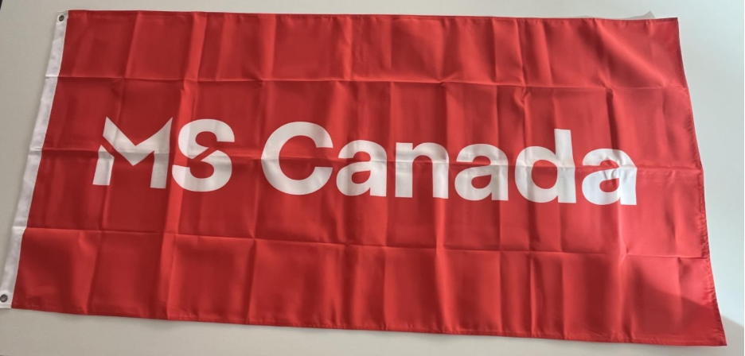
Purpose of flag raising/description of cause: Canada has one of the highest rates of multiple sclerosis (MS) in the world. Over 90,000 Canadians live with MS and on average, 12 Canadians are diagnosed with the disease every day. Every year on May 30, we celebrate global solidarity and hope for the future of people living and affected by MS through World MS Day (https://worldmsday.org/). For more information about MS and MS Canada, visit mscanada.ca

Are you also requesting a ceremony alongside the flag raising? If you’re planning to organize a flag raising ceremony as well, answer “yes” and provide any additional details, if required or applicable.

