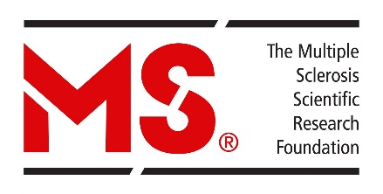

Returning Funds to the MS Society
Should your MS Society funded Grant or Award have residual funds at the end of the term outlined in your letter of agreement, they should be returned to the MSSC using one of the following methods:

For Domestic Institutions:
- Notify the MS Society by sending an e-mail to msresearchgrants@mssociety.ca outlining the name of the grant/award recipient, EGID number, and the reason for the residual funds.
- Funds must be returned via EFT using the following banking information:
Branch #: 06702
Transit #: 003
Account #: 0001388

For International Institutions:
- Notify the MS Society by sending an e-mail to msresearchgrants@mssociety.ca outlining the name of the grant/award recipient, EGID number, and the reason for the residual funds.
- Funds can be returned via cheque using the following mailing address to the attention of the “Research Department”:
MS Society of Canada
250 Dundas Street West, Suite 500
Toronto, Ontario M5T 2Z5
Canada

OR

Via Wire Transfer using the following information:

Swfit Code: ROYCCAT2

Should you have any questions or concerns regarding the returning of funds to the MS Society, please forward them to msresearchgrants@mssociety.ca.

